Services – Geolocation_20180201_GeoLocation_Set Automaticaly Time Zone Time and local time
We log. We create a trip. When we create the trip an interface shows up. We have Time zone field.

We need to have this time zone set to local time by default. Not local time server, local time client side (cell or tablet).

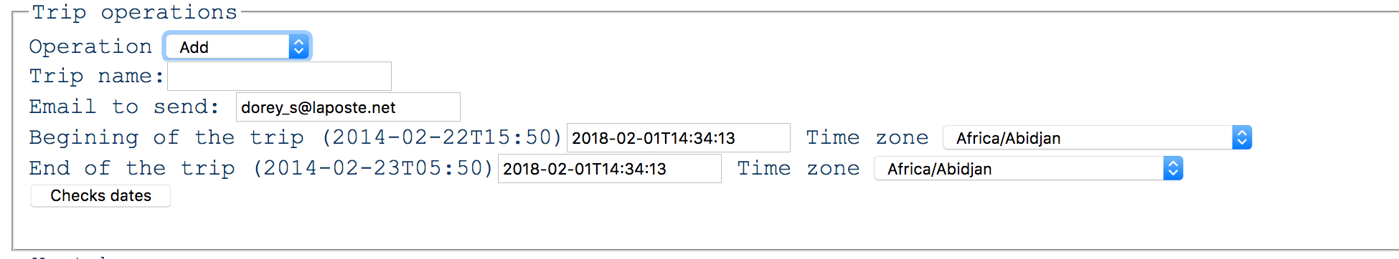
Interface used to declare trip

The beginning of the trip must be set to local time client not server.
We have two time zone field. Each fields must be independent to between each other when set. Hence the time of the trip must correspond to each time zone on the same line.

